

PLC Trend Tool
User Guide
Version 1.1.0
April 2026

Prepared by
Southern Automation Solutions
111 Hemlock St. Ste A, Valdosta, GA 31601
Contact@SASControls.com | 229-563-2897

Table of Contents
1. Getting Started ......................................................... 3
2. Connecting to a PLC ................................................. 4
3. Browsing and Selecting Tags ..................................... 6
4. Trending Data ............................................................ 8
5. Customizing the Chart ............................................... 11
6. Data Management ...................................................... 13
7. Application Settings ................................................... 14
8. Keyboard Shortcuts & Tips ........................................ 15
9. Troubleshooting ......................................................... 16

What’s New in Version 1.1.0
- Bit-Level Tag Drilling (ControlLogix): Integer-type tags (SINT, INT, DINT, LINT) and their array elements can now be expanded in the tag browser to access individual bits. For example, a DINT tag expands to show .0 through .31, allowing you to trend specific status bits within a word.
- Smart Tag Names: The legend, smart cursor tooltip, and line properties dialog now display tag names with enough context to be unique. Tags like _420_PIT_103.PV and _420_TT_101.PV show their full paths instead of both displaying as just “PV”.
- Display Settings Persistence: The Trend Properties Display tab checkboxes (legend, grid, scale, scrolling) now properly save their state when you click Apply & Close. Settings persist across sessions.
- Estimated Export Size Indicator: A new indicator in the sidebar near the connection status shows the estimated CSV export file size in real time. Color changes from gray to yellow to red as data grows, helping you decide when to stop and save.
- Dual Architecture Builds: Pre-built executables are now available for both x64 (Intel/AMD) and ARM64 (Windows on ARM) architectures. Use PLC_Trend_Tool_x64.exe for standard PCs and PLC_Trend_Tool_ARM64.exe for ARM-based devices.

1. Getting Started

1.1 Overview
The PLC Trend Tool is a portable desktop application for real-time trending of Allen-Bradley PLC tag data. It connects directly to your PLC over Ethernet/IP and displays live tag values as scrolling time-series charts with a synchronized data table below.
The application supports ControlLogix, CompactLogix, Micro800, SLC 500, MicroLogix, and PLC-5 controllers. No RSLinx or FactoryTalk installation is required.

1.2 System Requirements
Requirement | Details
Operating System | Windows 10 or later (64-bit). Pre-built exe available for x64 (Intel/AMD) and ARM64 architectures.
Python | 3.8 or later (for running from source)
Network | Ethernet connection to PLC network (same subnet)
Libraries | customtkinter, pylogix, matplotlib, Pillow (auto-installed via requirements.txt)
Optional | pycomm3 (required for SLC 500 / MicroLogix / PLC-5 support)

1.3 Installation
Option A: Run from Source
Step 1: Install Python — Download from python.org. Check 'Add Python to PATH' during installation.
Step 2: Download Source Files — Place all files in a single folder: plc_trend_tool.py, assets_data.py, build.py, requirements.txt
Step 3: Install Dependencies — Open a command prompt in the folder and run:
pip install -r requirements.txt
Step 4: Optional SLC Support — For SLC 500/MicroLogix/PLC-5 controllers:
pip install pycomm3
Step 5: Launch — Double-click plc_trend_tool.py or run from command prompt:
python plc_trend_tool.py
Option B: Build Standalone Executable
To create a single .exe file that runs without Python installed:
pip install pyinstaller
python build.py
The executable will be created in the dist/ folder as PLC_Trend_Tool.exe.
TIP: The build script automatically extracts logo assets, bundles all dependencies, and creates a single portable .exe file. Two pre-built versions are available: PLC_Trend_Tool_x64.exe for standard Windows 10/11 PCs (Intel/AMD), and PLC_Trend_Tool_ARM64.exe for ARM-based Windows devices (e.g., Windows on ARM via Parallels). Use the version that matches your processor architecture.

1.4 Application Layout
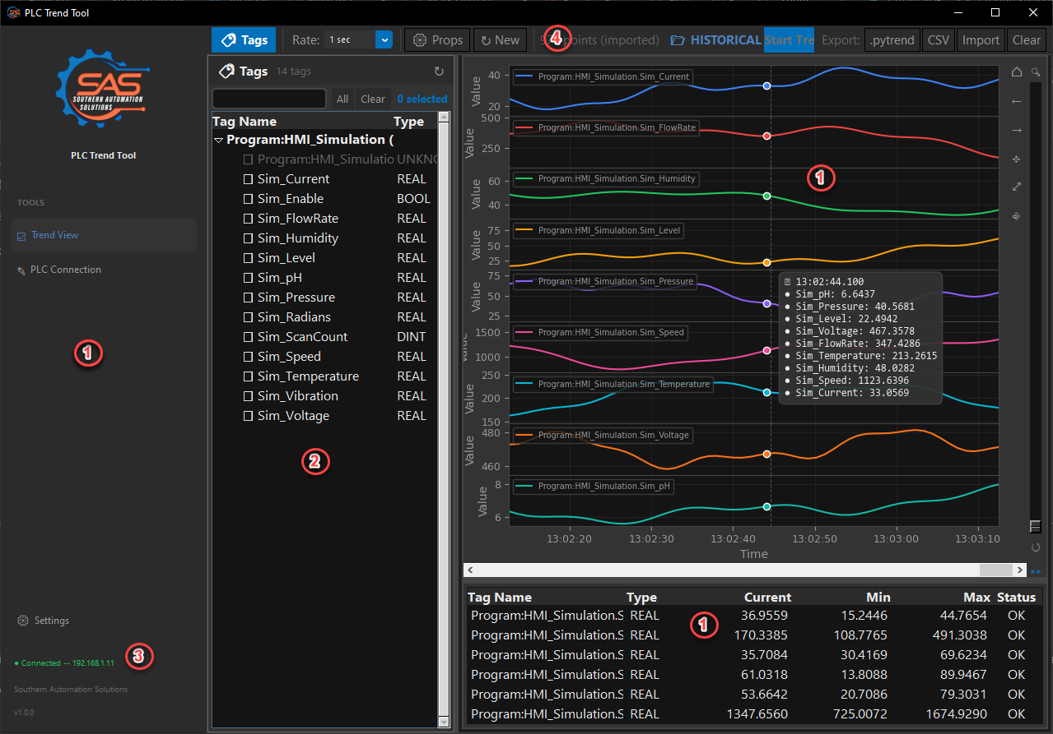
Figure 1: Main application window with all primary elements
1. Sidebar Logo — SAS branding with application name.
2. Tag Browser — Select tags to be trended by checking the box
3. Connection Status — Shows connected PLC IP, slot number, number of selected tags, and estimated export file size. The size indicator appears once trending begins and changes color based on data volume: normal (gray) under 50 MB, warning (yellow) up to 200 MB, and alert (red) above 200 MB.
4. Toolbar — Controls for trending, chart view mode, cursor, time settings, and data export/import.
5. Chart Area — Real-time trend chart with legend, grid lines, and time axis.
6. Live Data Table — Current values, min/max/average statistics, and data type for each trended tag.

2. Connecting to a PLC
Click the Connect button in the sidebar navigation to access the connection settings. The Connect view lets you specify your PLC's IP address, processor slot, and controller type.
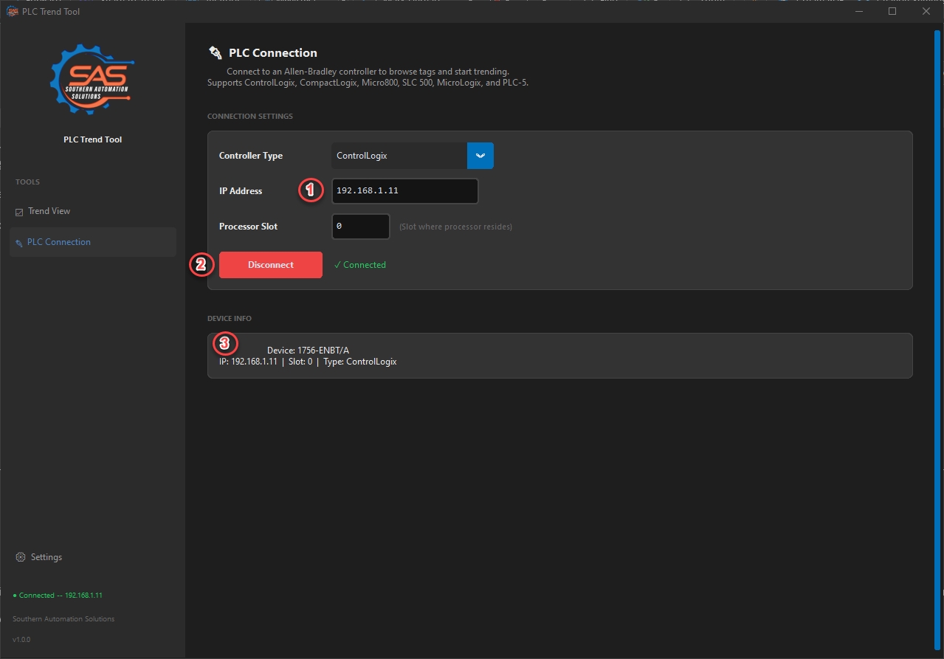
Figure 2: PLC connection settings
1. IP Address and Processor Slot — Enter the PLC's Ethernet IP address. Slot defaults to 0 (correct for CompactLogix). For ControlLogix, enter the slot number where the processor resides.
2. Connect / Disconnect — Click Connect to establish communication. The button toggles to show connection state.
3. Device Information — After connecting, displays the controller model, firmware revision, and serial number.

2.1 ControlLogix / CompactLogix
This is the default mode. Enter the IP address and processor slot, then click Connect. The tool uses the pylogix library to communicate via Ethernet/IP CIP protocol. After connecting, the tag browser automatically populates with controller tags, program-scoped tags, and UDT/AOI structure definitions.
TIP: CompactLogix processors are always in slot 0. ControlLogix processors can be in any slot within the chassis.

2.2 SLC 500 / MicroLogix / PLC-5
For legacy controllers, select 'SLC 500 / MicroLogix / PLC-5' from the Controller Type dropdown. This mode requires the pycomm3 library (install separately with pip install pycomm3).
After connecting, the tool automatically scans data files 0 through 255. Default files (O0, I1, S2, B3, T4, C5, R6, N7, F8) are always included. User-created files 9-255 are probed using typed probes (N, F, B, T, C, R, ST, A, L types) to detect which files exist in the controller.
WARNING: PLCs control dangerous equipment. Do not write tags to a live production system unless you understand the impact. This tool is designed for read-only monitoring.

2.3 Micro800 (820/850)
Check the Micro800 Mode checkbox before connecting. These controllers use a slightly different Ethernet/IP path. Note that Micro800 controllers have limited features compared to ControlLogix — not all tag browser capabilities may be available.

2.4 Connection Tips
- Ensure your PC is on the same subnet as the PLC (e.g., PLC: 192.168.1.10, PC: 192.168.1.100).
- If you cannot connect, try pinging the PLC IP address from a command prompt to verify network connectivity.
- The connection timeout is 5 seconds. If your network has high latency, you may need to retry.
- Disconnecting from a PLC fully resets the session — all trend data, tag selections, and chart customizations are cleared to prevent stale data when switching between different PLCs.

3. Browsing and Selecting Tags
After connecting to a PLC, click Tags in the sidebar or use the embedded tag panel on the Trend view to browse available tags. The tag browser presents a hierarchical tree view organized by scope and data type.
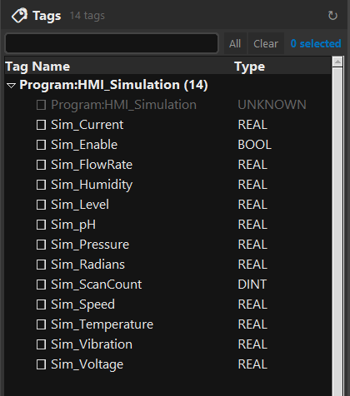
Figure 3: Tag browser showing ControlLogix and SLC tag structures

3.1 ControlLogix / CompactLogix Tags
Tags are organized under Controller Tags (global scope) and individual Program sections (program scope). Each tag shows its name and data type. You can expand UDT (User-Defined Type) and AOI (Add-On Instruction) structures by clicking the arrow to reveal their individual members.
Click the checkbox next to any fundamental data type tag (BOOL, SINT, INT, DINT, LINT, REAL, STRING) to select it for trending. Selected tags appear highlighted in the browser and are immediately added to the chart. Integer-type tags (SINT, INT, DINT, LINT) and their array elements can be expanded to reveal individual bit-level access (e.g., MyDINT.0 through MyDINT.31). This allows you to trend specific status bits within a word without trending the entire integer value. Expand any integer tag or integer array element to see a “whole word” option plus individual bit entries.
TIP: Use the search/filter bar at the top of the tag browser to quickly find tags by name. The filter matches anywhere in the tag name.

3.2 SLC / MicroLogix Tags
SLC tags are organized by data file number and type. The tree shows each detected data file with its type label (e.g., 'N7 - Integer', 'T4 - Timer', 'F8 - Float').
Integer Word Expansion (N, O, I, S Files)
Integer-type files (N, O, I, S) support bit-level expansion. Each word element (e.g., N7:0) can be expanded to reveal two levels of data:
- Whole Word (decimal): Trends the full 16-bit integer value as a decimal number. Labeled as 'N7:0 (word)'.
- Individual Bits (0–15): Each bit can be trended separately as a BOOL value (0 or 1). Labeled as 'N7:0/0' through 'N7:0/15'. This is useful when integer words are used as bit fields for status flags or inter-PLC communication.
You can trend the whole word and individual bits simultaneously on the same chart.
Timer / Counter / Control Expansion
Timer (T), Counter (C), and Control (R) file elements expand to show their individual fields:
Type | Numeric Fields | Status Bits
Timer (T) | ACC (accumulated), PRE (preset) | EN, TT, DN
Counter (C) | ACC, PRE | CU, CD, DN, OV, UN, UA
Control (R) | LEN, POS | EN, EU, DN, EM, ER, UL, IN, FD
Float and Long Integer Files
Float (F) and Long Integer (L) data files display their elements directly as trendable items without requiring expansion, since each element is already a single numeric value.

4. Trending Data
Once you have selected tags in the browser, use the toolbar to control the trend. The chart updates in real-time as data is polled from the PLC.
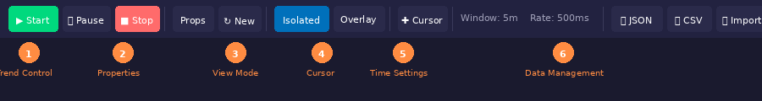
Figure 4: Toolbar with annotated control groups
1. Trend Control — Start, Pause, and Stop buttons control the data collection cycle.
2. Properties — Opens the Trend Properties dialog and the New Session reset button.
3. View Mode — Toggle between Isolated (separate subplot per tag) and Overlay (all tags on one chart).
4. Cursor — Enable/disable the smart crosshair cursor for reading values at any point in time.
5. Time Settings — Shows the current time window and poll rate.
6. Data Management — Export to JSON/CSV, import previous sessions, and clear data.

4.1 Starting and Stopping Trends
Step 1: Select Tags — Check one or more tags in the tag browser.
Step 2: Click Start — The green Start button begins polling the PLC at the configured rate (default 500ms). The chart begins scrolling with live data.
Step 3: Pause / Resume — Click Pause to freeze the display while continuing to collect data in the background. Click Resume to catch up and continue live display.
Step 4: Stop — Click Stop to end data collection. The chart freezes with all collected data available for review.
TIP: You can add or remove tags while the trend is running. New tags will begin appearing on the chart from the moment they are selected.

4.2 Isolated vs. Overlay View
The toolbar provides two chart view modes that affect how multiple tags are displayed:
Isolated Mode: Each tag gets its own dedicated subplot with independent Y-axis scaling. This is ideal when trending tags with very different value ranges (e.g., a temperature tag reading 0–500 alongside a boolean status flag reading 0–1). Charts stack vertically and share a synchronized time axis.
Overlay Mode: All tags share a single chart area with a common Y-axis. This is best when comparing tags with similar value ranges. The legend identifies each line by color.
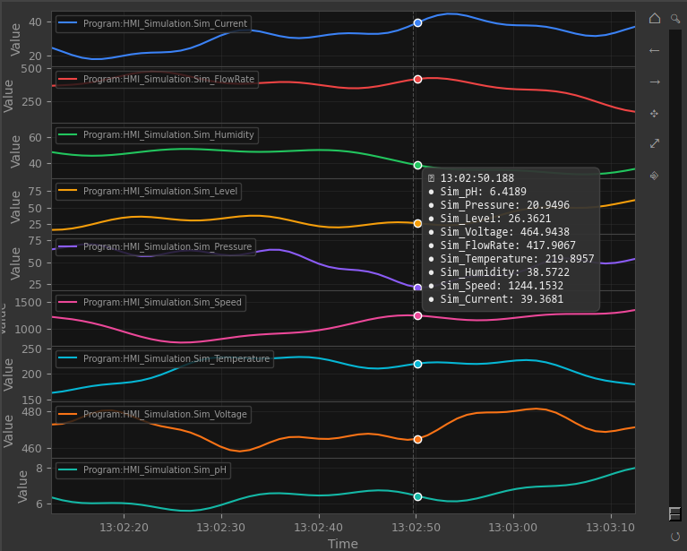
Figure 5: Isolated view with three tags, each in its own subplot with smart cursor active

4.3 Smart Cursor
Enable the cursor by clicking the Cursor button on the toolbar. When active, moving your mouse over the chart displays:
- A vertical dashed line tracking your mouse position across all subplots.
- Color-coded dots on each trend line at the nearest data point.
- A tooltip showing the exact timestamp and interpolated value for every active tag. Tag names are displayed using smart naming that preserves enough context to keep them unique (e.g., “_420_PIT_103.PV” and “_420_TT_101.PV” display their full paths instead of both showing just “PV”).
When the trend is stopped or paused, left-clicking on the chart locks the data table to show values at the clicked timestamp. This is useful for investigating specific moments in the data.

4.4 Chart Navigation
Action | How To
Pan (drag) | Click and drag on the chart to scroll through time. Works on both X and Y axes.
Zoom (scroll) | Use the mouse scroll wheel to zoom in/out on the time axis.
Follow Live | Right-click the chart and select 'Follow Live' to snap back to the current time and resume auto-scrolling.
Reset View | Right-click and select 'Reset View' to restore the original zoom and pan state.
Expand Chart | In Isolated mode, double-click any subplot to expand it to fill the entire chart area. Double-click again to return to the multi-subplot view.
Reorder Charts | In Isolated mode, hold Ctrl and drag a subplot up or down to change the display order.

4.5 Right-Click Context Menu
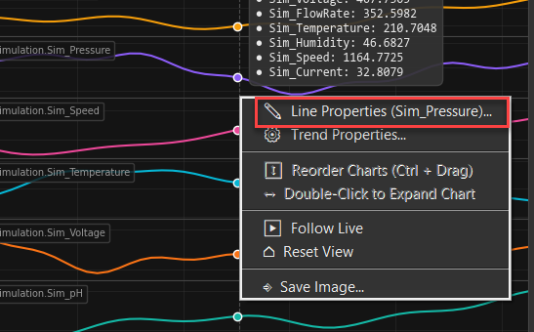
Figure 6: Right-click context menu on the chart area
Right-clicking anywhere on the chart opens a context menu with quick access to common actions. In Isolated mode, right-clicking inside a specific subplot targets that individual chart for line and background color customization.

5. Customizing the Chart

5.1 Line Properties
Access line properties by right-clicking the chart and selecting 'Line Properties', or by clicking the Props button on the toolbar. The dialog lets you customize each tag's appearance:
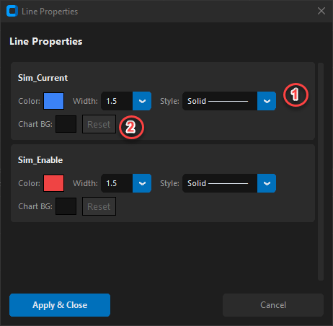
Figure 7: Line Properties dialog with color, width, style, and background controls
1. Line Controls — Set the line color (click the color swatch to open the system color picker), line width (0.5 to 5.0), and line style (Solid, Dashed, Dotted, Dash-Dot).
2. Chart Background — Set a custom background color for each tag's chart area. Click the color swatch to choose a color, or click Reset to revert to the default theme color.
Context-Aware Behavior
The Line Properties dialog adapts based on where you right-click:
- Right-click on grey/surrounding area: Shows properties for ALL tags in one dialog. In Overlay mode, any tag's background color applies to the shared chart.
- Right-click inside a specific subplot (Isolated mode): Shows properties for only that tag, letting you customize its individual chart appearance.

5.2 Trend Properties
Click the Props button or right-click and select 'Trend Properties' to open the configuration dialog.
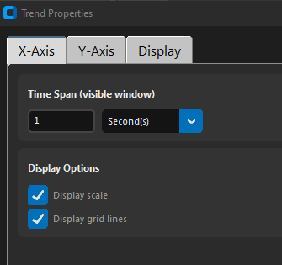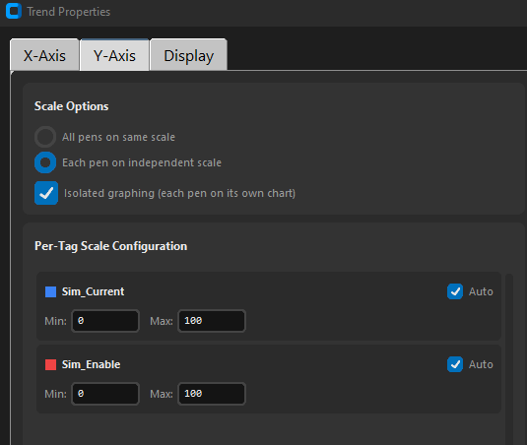
Figure 8: Trend Properties dialog with time, Y-axis, and display settings
Time Settings
- Time Window: How much historical data is visible on the chart at once (30 seconds to 4 hours). Use the quick preset buttons for common durations.
- Poll Rate: How frequently the tool reads values from the PLC (100ms to 10 seconds). Faster rates provide smoother charts but increase network traffic.
- Max Data Points: Maximum number of samples stored per tag. When exceeded, oldest points are discarded. Default is 50,000.
Y-Axis Scaling
By default, each tag auto-scales its Y-axis to fit the data range. You can override this with manual scaling by setting specific minimum and maximum values. This is useful when you want a fixed reference range (e.g., 0–100 for a percentage value).
Display Settings
The Display tab in Trend Properties provides toggle controls for chart display elements. All settings are saved when you click Apply & Close and persist across sessions:
- Display Line Legend: Show or hide the color-coded legend identifying each trended tag.
- Display Scale / Grid Lines: Toggle the X-axis time labels and grid lines on or off for a cleaner chart appearance.
- Allow Scrolling: Enable or disable mouse-wheel zoom and click-drag panning on the chart.
- Smart Cursor: Enable or disable the crosshair + value readout tooltip.

6. Data Management

6.1 Exporting Data
Two export formats are available from the toolbar:
JSON Export (.pytrend)
Saves the complete session including all tag data, timestamps, chart configurations, line properties, and scaling settings. This is the preferred format for archiving sessions that you want to reload later. Click the JSON button on the toolbar and choose a save location.
CSV Export
Exports tag data as a comma-separated values file compatible with Excel, Google Sheets, and other analysis tools. Each row contains a timestamp followed by the value for each tag. Click the CSV button to export.

6.2 Importing Data
Click the Import button on the toolbar to load a previously saved .pytrend or .csv file. The chart and data table will populate with the historical data, allowing you to review past trending sessions. When importing, the view switches to Historical mode, indicated by a badge in the toolbar.
TIP: You can import data without being connected to a PLC. This lets you review historical trends on any PC, even without network access.

6.3 Session Management
New Session (Reset): Click the ↻ New button on the toolbar to completely reset the application state. This clears all trend data, tag selections, chart customizations, line properties, and background colors. If still connected to a PLC, the tag browser reloads fresh. Use this when switching between different monitoring tasks on the same PLC.
Disconnect: Disconnecting from a PLC performs the same full reset as New Session, ensuring no stale data persists when connecting to a different PLC.
Clear Data: The Clear button removes all collected data points but preserves your tag selections and chart settings. Use this to start a fresh data collection without reconfiguring the display.

7. Application Settings
Click Settings in the sidebar to access application-level configuration.

7.1 Theme
Choose between Dark mode (default), Light mode, or System (follows your Windows theme setting). The dark theme is recommended for extended monitoring sessions to reduce eye strain.

7.2 Saved Settings
The application automatically saves your preferences to a plc_trend_settings.json file in the same directory as the application. Saved settings include: last IP address, processor slot, controller type, theme preference, time window, poll rate, max data points, and display options (legend visibility, grid lines, scale, scrolling, smart cursor). These are restored automatically on next launch.

8. Keyboard Shortcuts & Tips
Shortcut | Action
Ctrl + Drag (chart) | Reorder subplots in Isolated mode
Double-Click (chart) | Expand subplot to fullscreen / exit fullscreen
Right-Click (chart) | Open context menu with quick actions
Scroll Wheel (chart) | Zoom in/out on time axis
Click + Drag (chart) | Pan through time / adjust view
Left-Click (stopped) | Lock data table to show values at clicked timestamp
Filter bar (tag browser) | Type to filter tags by name — matches partial strings

8.1 Performance Tips
- Trend only the tags you need. Each additional tag adds network overhead and chart rendering load.
- For high-speed monitoring (100ms poll rate), limit to 5–10 tags for best performance.
- Use Isolated mode when trending tags with very different value ranges to avoid Y-axis scaling issues.
- Reduce the Max Data Points setting if the application becomes sluggish during long trending sessions.

9. Troubleshooting
Issue | Solution
Cannot connect to PLC | Verify IP address and subnet. Ping the PLC from command prompt. Check Ethernet cable. Ensure processor slot is correct.
Tag shows 'None' / error | The tag name may not exist. Verify spelling and scope (controller vs program tags). Check that the data type is supported.
SLC scan finds too many files | This was a known issue with false positives from O/I memory mapping. Update to the latest version which uses typed probes only.
SLC scan finds too few files | User files beyond 8 are scanned using typed probes (N, F, B, T, C, R, ST, A, L). Unusual file types may not be detected.
Old data from previous PLC | Click the New Session button or disconnect and reconnect. Both operations fully reset all session state.
Chart scaling jumps | This can occur with cursor enabled if the auto-scale reacts to cursor elements. Update to latest version for the fix.
Logo/icon missing | Ensure assets_data.py is in the same folder as plc_trend_tool.py. The app extracts icons from this file on first launch.
pycomm3 not found | SLC/MicroLogix/PLC-5 support requires pycomm3. Install with: pip install pycomm3
App crashes on startup | Verify all dependencies: pip install -r requirements.txt. Check Python version is 3.8+. Delete plc_trend_settings.json to reset.

────────────────────
End of User Guide
For technical support or feature requests:
Mark Patera | Mark@SASControls.com | 229-563-0359
Southern Automation Solutions | 111 Hemlock St. Ste A, Valdosta, GA 31601

